One Unit and Three Lesson Plans
Class: Early Childhood
Date: Fall 2009

Amy Mulloy 11/17/09 Box #7562

Continents: Africa, Asia, Australia
Unit Plan

- Goals:
Students will be able to describe distinctive features about each of the three continents.
3.1.02 Discuss the cultures and human patterns of places and regions of the world.

Students will identify characteristics of some the cultures represented in the three continents.
3.1.01 Understand the diversity of human cultures.

Students will describe important people in the history of the three continents.
3.1.03 Recognize the contributions of individuals and people of various ethnic, racial, religious, socioeconomic groups to the development of civilizations.

Students will match specific music, food, clothing and art to the three continents.
3.1.spi.1. recognize some of the major components of a culture

Students will match main culture groups with its specific continent.
3.1.spi.4. interpret a chart or map identifying major cultural groups of the world.

- Specific ways the goals integrate subject to curriculum:
Use textbooks for more in depth study of countries.
Use real life stories to enhance the textbook.

- Grade level/subject
Third Grade Social Studies

- Activities planned:
- Continent: Africa Day
- Continent: Asia Day
- Continent: Australia Day

- Assessment of learner understanding
Class presentations (presenting their in class work to the class).
Answering questions asked by the teacher (class participation).
“World Travelers” booklet with completed country summaries.
Matching worksheet exercises.
Working in a group to reach a goal (group participation).
Art work
Costume design and dress up
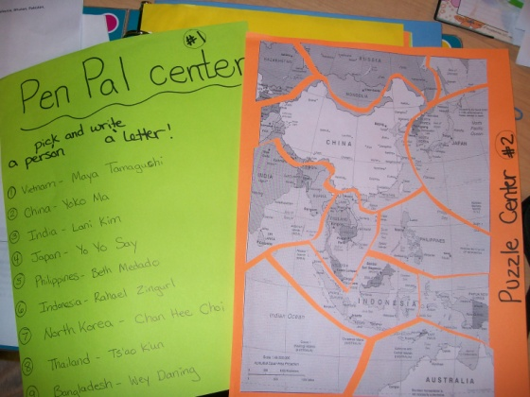
Center Activity

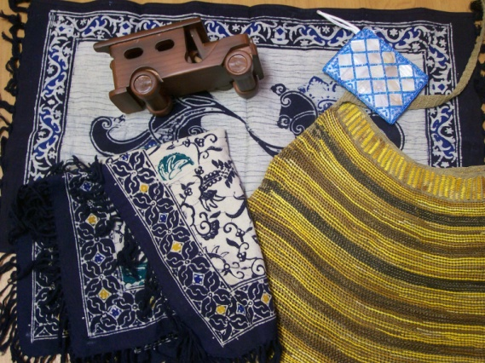 Sample artifacts from other countries

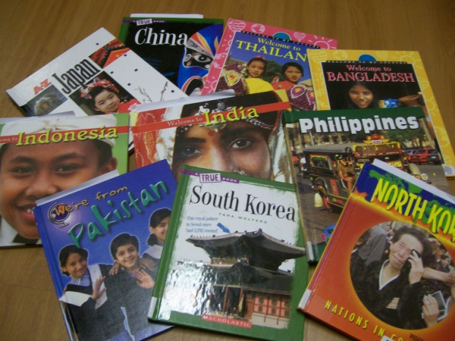 Textbooks to use in the classroom

Amy Mulloy 11/17/09 Box #7562

Continent of Africa
Lesson Plan #1

- Concept to be taught
One of the seven continents, Africa, has a large land area with diverse terrains, countries, and cultures stretching between its boundaries.

- Instructional Objectives
Students will compare and contrast their lives in the United States with that of African children.
3.1.01 Understand the diversity of human cultures.
3.1.02 Discuss the cultures and human patterns of places and regions of the world.

Students will be able to describe characteristics of traditional African artwork.
3.1.spi.1. recognize some of the major components of a culture

- Materials Needed
Paper
Art supplies- glue, paint, markers, glitter, etc.
Shoeboxes
Lion King movie

- Classroom teaching strategies and procedures
  - Anticipatory set
Group time- teacher will read a story about a brother and sister living in Africa

  - Student learning activities
    - Teacher will:
Read a story about African children.
Show examples of African artwork.
Find and play short movie clips in the Lion King movie that pertain to the lesson.

    - Students will:
Make their own version of African artwork with the art supplies provided.
Watch clips from the Lion King that show what some of the African terrain is like.
Pick any African terrain (forests, mountains, desert) and reproduce it in a shoebox.

  - Conclusion
    - Students will:
Present their African artwork to the class.
Identify some traditional African artwork elements in their own artwork.

  - Activity extension
    - Matching worksheet of the many terrains and their locations in Africa.

- Evaluation
  - How will student learning be measured
    - Identification of traditional African elements in his/her own artwork
    - Evidence of a specific terrain in the shoebox reproduction

  - Re-teaching procedures if necessary
    - Make it a movie day or reward day and watch the whole Lion King movie. Have the students point out the different terrains that they saw while watching the movie.

  - Possible changes to lesson plan to increase effectiveness
    - Invite an African artist to speak to the class and show some of his artwork

Amy Mulloy 11/17/09 Box #7562

Continent of Asia
Lesson Plan #2

- Concept to be taught
Of the seven continents, Asia is one that includes many countries with diverse backgrounds.

- Instructional Objectives
Students will gain an appreciation for some of the different people groups in Asia.
3.1.01 Understand the diversity of human cultures.

Students will be able to compare and contrast different countries in Asia.
3.1.02 Discuss the cultures and human patterns of places and regions of the world.

Students will learn about famous Asian people that have made their mark in history.
3.1.03 Recognize the contributions of individuals and people of various ethnic, racial, religious, and socioeconomic groups to the development of civilizations.

Students will listen to music from various countries in Asia.
3.1.spi.1. recognize some of the major components of a culture.

Students will learn about the basic ways of living in some countries in Asia.
3.1.spi.2. determine similarities and differences in the ways different cultural
groups address basic human needs

- Materials Needed
World Map
Textbooks or at least a paragraph of information about each country in Asia
“World Traveler” booklet
“Secret Bag” with asian artifacts
Music from Asia

- Classroom teaching strategies and procedures
  - Anticipatory set
    - Dress up and wear Asian clothes to class
    - Show the world map and describe seven continents
    - Ask children to find the United States
    - Begin talking about the continent of Asia
  - Student learning activities
    - Teacher will:
      - Explain that Asia is one of the seven continents
      - Pull articles out of the mystery bag and talk about how they are unique
      - Explain the “World Travelers” booklet
      - Hand out books about individual countries (two people per country) and booklets to each person
      - Play asian music while students are reading and writing

    - Students will:
      - Locate the United States on a world map
      - Read the book on their specific country (along with a partner) and fill out the “World Travelers” booklet of country information
      - Draw their asian country and label the cities, rivers, and bodies of water
      - Draw their asian country’s flag

  - Conclusion
    - Students will:
      - Present their asian country information in their “World Travelers” booklet to the class.

  - Activity extension
    - Draw the continent of Asia instead of just one Asian country.

- Evaluation
  - How will student learning be measured
    - Completion of questions in their “World Travelers” booklet
    - Presentation to the class

  - Re-teaching procedures if necessary
    - Movies, pictures or books to provide more visual images of people in different cultures

  - Possible changes to lesson plan to increase effectiveness
    - More discussion in the beginning about what students had heard previously about Asia
    - Provide a sample food made in asia for students try.

Amy Mulloy 11/17/09 Box #7562

Continent of Australia
Lesson Plan #3

- Concept to be taught
Australia, one of the seven continents, has a large Aborigine population and many animals unique to its location.

- Instructional Objectives
Students should compare and contrast the Aborigine to the modern day Australian.
3.1.01 Understand the diversity of human cultures.
3.1.02 Discuss the cultures and human patterns of places and regions of the world.
3.1.03 Recognize the contributions of individuals and people of various ethnic, racial, religious, socioeconomic groups to the development of civilizations.
3.1.spi.4. interpret a chart or map identifying major cultural groups of the world.

Students will be recognize able to say some phrases in Aboriginal language
3.1.spi.1. recognize some of the major components of a culture

Students will taste some traditional foods of Australia.
3.1.spi.1. recognize some of the major components of a culture

- Materials Needed
Aborigine man or woman to speak to the class
Traditional Australian food
Steve Irwin episodes

- Classroom teaching strategies and procedures
  - Anticipatory set
(the day before, the teacher will send out a letter to parents informing them that each student should come to school the next day, dressed as any animal from Australia)

The teacher and each student will describe the animal that he/she is dressed up as.

  - Student learning activities
    - Teacher will:
Dress up as an Australian animal.
Introduce the Aborigine speaker/guest speaker from Australia.
Talk about the animals of Australia.
Show episode of Steve Irwin’s adventures.
Conduct class discussion about the Aborigines.

    - Students will:
Dress up as an Australian animal.
Ask the guest speaker questions about Australia.
Sample food from Australia.
Watch episode of Steve Irwin’s adventures and notice the animals he comes in contact with.

  - Conclusion
    - Students will:
Create a list of all the animals they noticed in the Steve Irwin clips.

  - Activity extension
    - Bring some exotic animals to class.

- Evaluation
  - How will student learning be measured
    - Dress up like an animal of Australia
    - Participation of class discussion and interview with guest speaker

  - Re-teaching procedures if necessary
    - Teach the lesson on Australian animals, then the next day have the students dress up after they have learned about some of the animals (instead of the students researching it themselves at home and dressing up the night before)

  - Possible changes to lesson plan to increase effectiveness
    - Include more concrete ways to assess student learning

