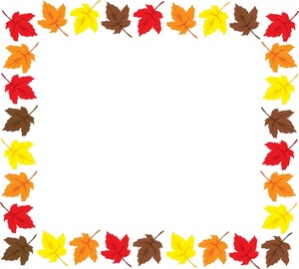

Faith Academy’s Fall Festival!

Saturday, October 29

12-3 pm

Bring your family for a time of fun fall activities.

Class Field Trip to Fred’s Pumpkin Patch

Wednesday, October 26

**History**: civil War

**Reading**: story elements

**Grammar**: subject, verb, adjective

**Science**: solar system, earth science

**Social Studies**: government

**Math**: place value, renaming

October…

in Miss Mulloy’s 2nd Grade!